## Introduction

With the global climate change and temperature rise there’s constant effect on the polar ice sheet thus making significant change in the rise of sea level. Huge efforts have been made to study the ice sheet conditions especially the Antarctic and Greenland ice sheet which can bring about a significant change in the sea level rise. Scientists have been constantly monitoring these ice sheets and studying the ice sheet conditions. Several models have been proposed to explain the ice sheet conditions and are constantly used to explain the ice conditions. Ice sheet dynamics play important role in explaining the glaciers and melting. Ice motion is affected by two main factors i.e. temperature and the strength of the bases. A lot of ice breaks due to the melting of ice sheets both superficially as well as the basal melting. The ice slides due to basal melt which is caused by high pressure from thick ice sheet. The melting point of water decreases with the increase in pressure thus thicker glacier are likely to cause basal melt as well as they also provide thermal insulation meaning higher temperature favorable for melting. Ice sheet loss is then caused due to sliding of ice sheets into the oceans. So studying the basal conditions of these ice sheets play a crucial role in accessing the climate change.

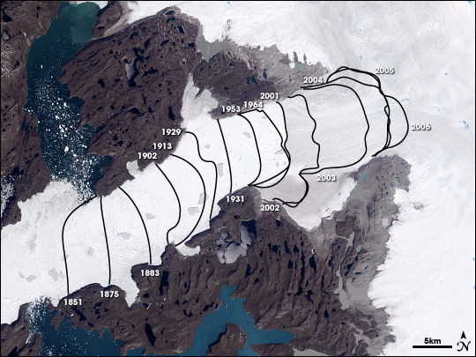

Figure 1. Jakobshavn Glacier

Figure 1 shows the retreat of Jacobshavn glacier in Greenland which is retreating inland at a very high rate directly indicating the alarming rate at which the melting of ice sheets is occurring.

RES have been extensively used in polar surveys. The data collected by these radars have been used to understand ice dynamics and subglacial conditions. Based on the radar signal intensity from the ice bed, distinctions between basal water and rocks can be made [1] where strong ice bed reflections correspond to basal melt. Certain subglacial lakes have been identified both in Greenland and Antarctica [3,4,5]. However, the ice bed reflectivity first needs to be properly compensated for the geometrical spreading loss, ice attenuation, and rough surface scattering. To calculate the bed reflectivity, the effects of rough beds need to be compensated for otherwise frozen beds may be misidentified as basal melts due to higher reflectivity.

Radar Equation

The radar backscattered echo strength varies when reflected from different types of interfaces because of its dielectric values and nature of the surface. Reflectivity is related to reflected power that is received by the radar receiver.









As we can see the reflectivity of ice water interface is pretty high when compared to ice rock interface so we can expect higher received power from the ice water interface and lower from ice rock interface thus this property can be analyzed from the bed echo strength to make distinction between frozen bed and basal melt.

However there are also certain loss factors that needs to be compensated first before looking at the ice bed echo strength. When radar signal moves through the ice then there is attenuation of signal and based on the depth of the bed, type of the ice and its constituents, roughness of the interface and so on, hence this needs to be compensated first before getting the final bed reflectivity.

When signal propagates through the ice, the bed echo strength is given by the equation

$${[P]}_{dB}={[S]}_{dB}-{[G]}_{dB}+ {[R]}_{dB}- {\left[L\right]}_{dB}$$

where Bed echo strength (P) is function of radar system parameters(S), geometric spreading loss(G), bed reflectivity(R), englacial attenuation (L). So we need to calculate the reflectivity ‘R’ of the bed compensating all the other parameters from the bed echo strength ‘P’.

Challenges in Estimation of Ice Bed Reflectivity

As previously discussed before the received ice bed power incorporates certain components in it like englacial attenuation, interface roughness loss, dielectric constant, slope effects, roll effects, etc. Thus only after proper compensation i.e. from eqn 1, we can determine the ice bed reflectivity. There are ceratin uncertainties in the estimation of englacial attenuation because it varies with location as well as correct prediction of interface roughness and ice bed dielectric is difficult. However differebnt methods have been used to determine the englacial attenuation and the interface roughness.

Chapter 2

Estimation of Roughness

Roughness compensation is important in determining the ice bed reflectivity but along with that bed roughness is also one of the important basal parameters that can explain ice dynamics [6]. Bingham and Siegert, 2009 present two examples from West Antarctica, which demonstrate the utility of bed roughness in determining the presence and extent of subglacial sediments, glacial dynamics and former ice-sheet size [7]. Fast flowing ice corresponds to a smoother bed and slower to rougher beds [8,16]. The changes of the ice sheet conditions are being monitored by flying missions over the same place in certain time period. One of the changes that can be identified is the change in the surface roughness that can show the changing nature of ice dynamics at that place.

Roughness can be estimated from RES data using different methods like Fast Fourier transforms [9], Integral Equation Model [10] and statistical method [11]. The MCoRDS radar used by the Center for Remote Sensing of Ice sheets (CReSIS) for polar surveys can penetrate deep into ice sheets to reveal ice bottoms and the backscattered signal from the bed [13,14]. These bed echoes are analyzed to understand the basal conditions [1,15]. We apply Grima’s approach to derive roughness of the ice bed and ice surface, which can be used to model ice bed reflectivity and understand basal conditions.

Roughness is a function of the radar system parameters as it varies with the wavelength of the radar signal. Roughnesses calculated by the MCoRDS [13] are compared with that of laser altimeter by ATM group [17] and Ku Band altimeter [19]. However, RMS height is an inherent property of the system parameters [20] hence these systems are expected to have quantitatively different results but qualitatively similar results, which gives us confidence towards the calculation of ice bed reflectivity. Laser altimeter and Ku-band maps only the ice surface hence here we compare the surface RMS heights calculated from these three systems.

METHODOLOGY

*A. Data Collection*

The Center for Remote Sensing of Ice Sheets (CReSIS) deployed airborne Multi Channel Coherent Radar Depth Sounder (MCoRDS), a nadir looking radar mounted on an aircraft flying usually at the height of 500 meters from the ice

surface to map the thickness of Greenland and Antarctica ice sheets in NASA’s Operation Ice Bridge (OIB) missions [13,19]. This analysis studies the surface roughness of Peterman Glacier, which was mapped using MCORDS in 2010-2014 [14].

MCoRDS operates with linear chirp waveform within the frequency band from 180 MHz to 210 MHz. It usually has six transmit channels and receivers to allow beamforming during data processing. An Arbitrary waveform generator (AWG) is used to generate the waveforms which is pre-stored in digital form and converted to analog form using a D/A converter [6]. Three different pulses are used. The short pulses of 1 μs and 3 μs are used to detect the surface and shallow ice layers and doesn’t have high penetration power whereas 10-μs pulse is better in detecting the ice bed as it has higher penetration power. The short and long pulses are alternatively sent with time division multiplexing at pulse repetition frequency of 12 KHz. The received signals are digitized using A/D converters at sampling rate of 111MHz or 150 MHz with 14 ADC bits. Table I. describes some basic radar system parameters.

RADAR Specifications

|  |  |
| --- | --- |
| **Description** | **Characteristic** |
| Center Frequency | 195 MHz |
| Bandwidth | 180-210 MHz |
| Transmit Signal Type | Linear Up Chirp |
| Transmit Power | 1050 W |
| Signal Duration | 1 μs and 10 μs (Low  Altitude) 30 μs (High Altitude |
| Transmit Channels | 7 |
| Receive Channels | 16 |
| Noise Figure | 2 |
| Sampling Rate | 111 MHz |
| ADC Bits | 14 |
| Dynamic Range | Waveform Playlist |
| Data Rate | 32 MB/sec per channel |

The complex data received after processing from this radar has along track resolution of about 0.5 m which is surface tracked in the echogram-using the tracker developed by CReSIS to derive the surface echo amplitudes.

The surface illuminated by the radar or its footprint is important is deriving the surface roughness. For any radar, the footprint bounded by compressed pulse length is given by [11]:

𝐷𝑃𝐿=2√ℎ𝑐Δ𝑓 (1)

where ‘h’ is the height of the aircraft from the surface, Δ𝑓 is the bandwidth of the radar signal. For MCoRDS, the flying height is typically 500 meters and the bandwidth being 30 MHz the radar footprint thus averages around 141 meters for ice surface and for average ice depth of 2000 meters, the footprint is around 316 meters. Surface roughness can be characterized by root mean square height 𝜎ℎ and correlation length (𝐿𝑐) but recent studies derive 𝐿𝑐 directly from 𝜎ℎ with insitu instrumentations [20]. The echo amplitudes of the surface and ice bed are fitted using rice distribution for every 200 m with overlapping of every 100m to calculate the coherent and incoherent powers and then from power statistics, derive the RMS height of the surface [11].

Surface roughness calculations are also made from the Airborne Topographic Mapper (ATM), a conical scanning airborne laser developed at NASA Wallops Flight Facility to monitor the earth’s topography. ATM measures the surface elevation based on the two-way travel time of laser pulses along with the differential GPS and aircraft attitude information. It operates at 532 nm with a pulse repetition frequency of 5 kHz and a scan rate of 20 Hz [18]. The along-track resolution is 3-4 m with laser footprint of ~1m. The primary data product of ATM is QFIT, which is dense surface elevation measurements. It is condensed into ICESSN which fits a plane to the block of points selected at regular intervals (0.5 sec) along track with overlapping of 50% between successive blocks [17]. It also measures the South-North and West-East slope for the plane and RMS fit of the ATM data to the plane. The radar lines of MCoRDS coincide with the track 0 of ICESSN data. ICESSN data has along-track resolution of 80 meters and hence the RMS height from this laser system is calculated by the interpolation for the corresponding radar locations.

In addition, Operation IceBridge missions also employ the Ku-band Altimeter developed by CReSIS which is an Ultra Wideband Frequency (UWB) Modulated Continuous wave (FMCW) radar operating usually from 12-18 GHz [19]. It provides high precision surface elevation measurements over polar ice sheets. The along-track resolution of the data from Ku- band is 0.2 meters after hardware presums.

## Theory and Data Processing

Reflection and scattering of EM waves are affected by the roughness of the surface. From specular surfaces the received field is coherent with known phase given by $E=A e^{jα}$ $E=A e^{jφ_{0}}$ whereas from rough surfaces they are scattered with unknown phase called the incoherent components [24]. Both the coherent and incoherent components contribute to the total signal received at the radar receiver, which can be written as:

$E=e^{jφ_{0}}+\sum_{i=1}^{N}{Ae^{jφ_{i}}}$ $$E={A_{0}e}^{jφ_{0}}+\sum_{i=1}^{N}{{A_{i}e}^{jφ_{i}}} (2)$$

where the first part is the coherent component with amplitude $A_{0}$ and phase $φ_{0}$, and the second part is the incoherent component which is a summation of the fields of N random scatters with amplitude $A_{i}$ and phase $φ_{i}$. The balance between these two components is a function of surface roughness [19].

Grima proposed a statistical method in which the coherent and incoherent components can be extracted by fitting the amplitude distribution of received signals to statistical models [25]. Different statistical models have different domains of validity that are related to the characteristics of natural surfaces. Grima uses the homodyne K-distribution to model the surface which is valid even at the limiting case, however, it does not have a closed form and is difficult to solve [19]. Specular surfaces tend to correlate with Rician fitting while rougher surfaces correlate with K-noise statistics. The ice surface and bed echo amplitude here are fitted with the Rician distribution as the domain of validity of Rician distribution fitting is large. The Rician distribution fitting fails only when N, the reflector population in the footprint, is a random variable with a negative-binomial distribution. The Rician distribution is given by

$P(A|a,s)=\frac{A}{S^{2}}e^{-\frac{A^{2}+a^{2}}{2s^{2}}}I_{0}(\frac{aA}{s^{2}})$ $P(A|a,s)=\frac{A}{S^{2}}e^{- \frac{A^{2}+a^{2}}{2s^{2}}}I_{0}(\frac{aA}{s^{2}})$ (3)

for interval [a, ∞] where $I_{0}\left(z\right)$ is the modified Bessel function of first kind with zero order and ‘*a*’ and ‘*s*’ are the shape parameters. From the Rician fitting, the coherent and incoherent power are obtained as:

$${\text{P}}_{\text{c}}\text{=}{\text{a}}^{\text{2}}\text{ (4)}$$

$${\text{P}}_{\text{n}}\text{=2 }{\text{s}}^{\text{2}}\text{ (5)}$$

The ratio of coherent and the incoherent power is related to the RMS height as [19]

$$\frac{{\text{P}}_{\text{c}}}{{\text{P}}_{\text{n}}}\text{=}\frac{{\text{e}}^{\text{-}{\text{(2k}{\text{σ}}_{\text{h}}\text{)}}^{\text{2}}}}{\text{4}{\text{k}}^{\text{2}}{{\text{σ}}_{\text{h}}}^{\text{2}}}\text{ (6})$$

where $k=\frac{2π}{λ}$ is the wave number. The coherent power $P_{c}$ and incoherent power $P_{n}$ derived from the statistical power distribution fitting are used in Eq. (6) to derive the RMS height $σ_{h}$ for the radar.

Similarly based on the surface elevations obtained from Ku-band altimeter, RMS height was calculated using samples within along-track distance of every 200 m with 50% overlapping as:

$${\text{σ}}_{\text{h}}\text{=}\sqrt{\frac{\text{1}}{\text{n}}\sum_{\text{i=1}}^{\text{n}}{{\text{(}{\text{z}}_{\text{i}}\text{-}{\overline{\text{z}}}_{\text{i}}\text{)}}^{\text{2}}}}\text{ (7)}$$

The radar lines of MCoRDS coincide with the track 0 of ICESSN data. ICESSN data has along-track interval of about 30 meters and hence the RMS height from this laser system is interpolated at the corresponding radar locations.

The reduction factor of the received power caused by roughness is [4, 26]

$$\text{ρ=}{\text{e}}^{{\text{-σ}}_{\text{∅}}^{\text{2}}}{\text{I}}_{\text{0}}^{\text{2}}\left(\frac{{\text{σ}}_{\text{∅}}^{\text{2}}}{\text{2}}\right)\text{ (8)}$$

where $I_{0}$ is zeroth order modified Bessel function of first kind,

$σ_{∅}$ is the phase variation due to surface roughness given by [27]

$${\text{σ}}_{\text{∅}}\text{=}\frac{\text{4π}{\text{σ}}_{\text{h}}}{\text{λ}}\text{ (for ice surface ) (9)}$$

$$σ_{∅}=\frac{4πσ_{h}}{λ}\left(\sqrt{ε}-1\right) (\text{for ice bed}) (10)$$

where $ε$ is the ice dielectric constant at the ice surface. The correction $ρ$ is applied at each location along survey lines in order to compensate for the losses due to rough surface.

The radar data used for analysis were collected by CReSIS using MCoRDS in 2010-2014 season in Greenland. The particular segment 20141026_02 from Antarctica, as shown in the red line in Fig.1, is used to analyze the validity of the above methods because of the good quality of data, and the variable surface roughness as seen from the Ku-band altimeter in Fig. 2. Areas with smooth surface can be seen in Fig. 2a and rougher surface from Fig. 2b with their corresponding Ku-band radar echograms in Fig. 2c and Fig. 2d.

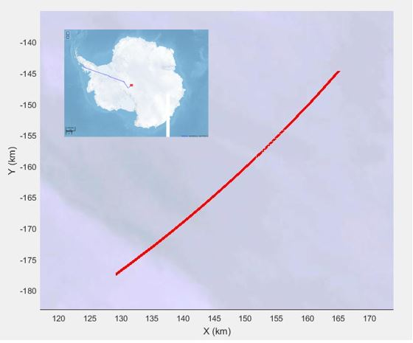

Fig. 1. Area used for Roughness Comparison and Verification

The amplitude distribution is fitted to the Rician distribution for every 500 data records from MCoRDS (i.e. about 200-m along-track distance) to derive the surface RMS height according to Eq. (3) to Eq. (6). For the purpose of validation, the RMS height was also derived for the corresponding radar locations using Ku-band and laser altimeter data. Figure 3 shows the comparison between the surface roughness measurements obtained from three systems, with the red indicating radar, blue indicating laser and green indicating Ku-band measurements. It can be clearly observed that the RMS height calculated corresponds to the surface features seen in the Ku-band altimeter image. The rougher surface features from the echogram coincide with the corresponding higher value of RMS height whereas same for the comparatively smoother surfaces of lower RMS value.

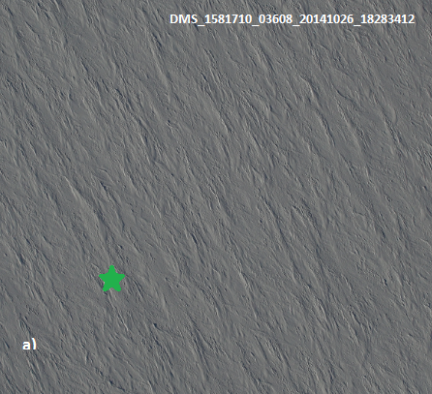 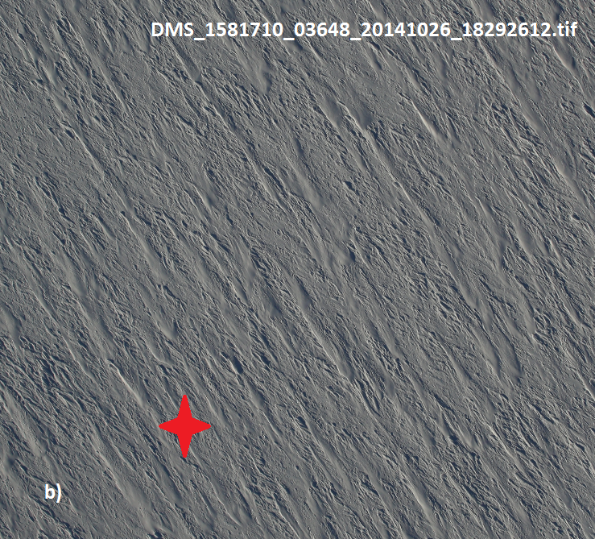

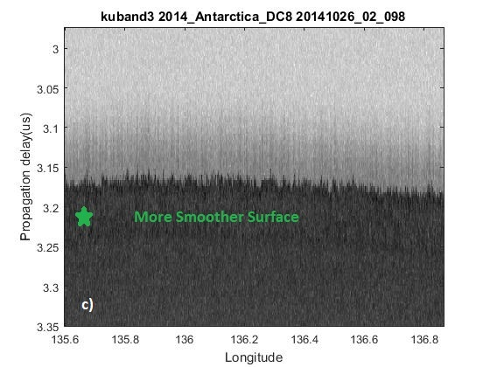 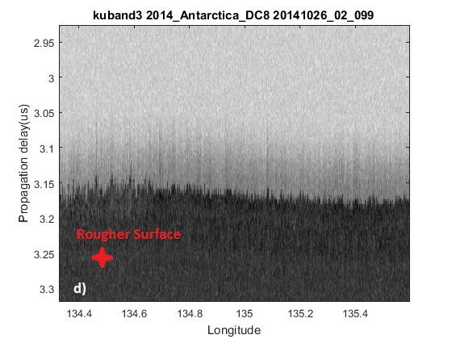

Fig.2. DMS pictures of areas with Smoother (a) and Rougher (b) Surfaces [29]. Radar Echograms obtained from Ku-band altimeter showing corresponding smoother (a) and rougher areas (b)

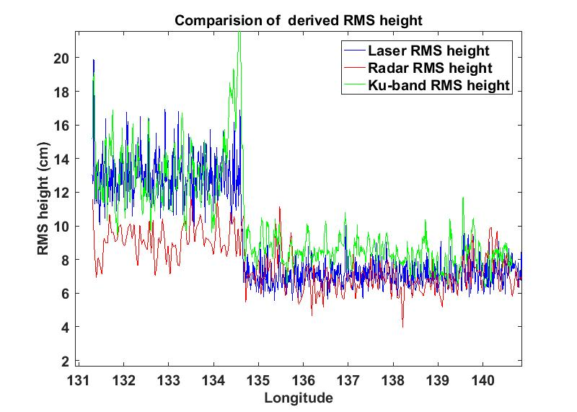

Fig. 3. Surface RMS heights obtained from MCoRDS (red), ATM (blue) and Ku-band altimeter (green)

It can be distinguished that the areas with higher RMS in laser data are also seen rough by the radar. However there is a certain bias which can be owed to the facts that these are two different systems operating with different system parameters and surface roughness is the inherent property of radar specifications [22]. The RMS heights detected by radar are bounded for rougher area and this might be the more evident amplitude fading effects with increasing roughness [19]. In addition, the RMS heights derived from the Ku-band altimeter measurements are similar.

Following the comparisons and verifications, we used the same method to determine the surface and bed roughness of Peterman Glacier, which can be later used to calibrate the calculation of the ice bed reflectivity. The survey lines in grid over the glacier extend from inland towards the ice margin as well as from east to west. Straight lines are chosen as there’s no loss due to aircraft banking.

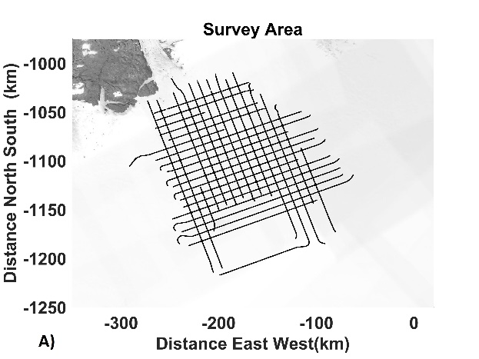 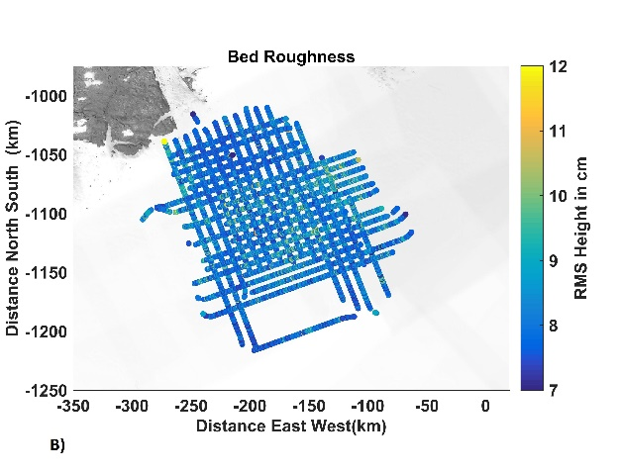

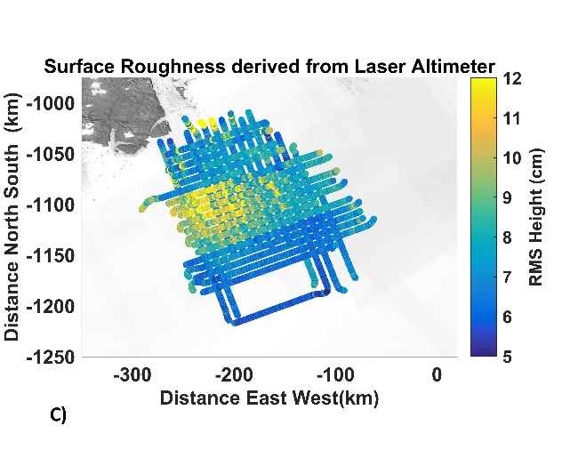 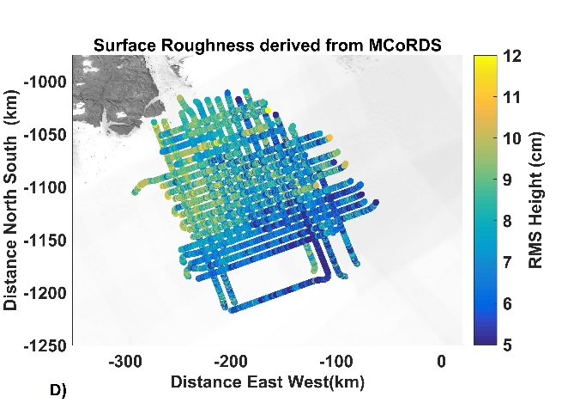

Fig. 4. Radar Survey area of Petermann Glacier under Operation IceBridge (A), Bed Roughness calculated from MCoRDS (B), Surface Roughness calculated from MCoRDS (C), Surface Roughness calculated from ATM (D),

The surface roughness for Peterman Glacier was obtained using radar data and laser data as presented in Fig. 4. The result from Ku-band data are not presented because the data are not complete over this area. However crossover checks have been carried out wherever the data are available. Crossover analysis for obtained roughness has shown 75% of the RMS height difference is within ±2 cm. The results reveal that the surface roughness is greater towards the coastline, which is expected since the ice flow is obstructed at the coastline due to narrow passage. Higher RMS height values are seen towards the Northwest area. The difference between the radar derived RMS heights and laser derived RMS heights is within ±5 cm (99%) for the survey area as shown in Fig. 5.

Fitting errors maybe introduced when RMS height is fitted into Eq. (6), so it should be checked for convergence. Some of the errors of this method may result from the surface and bottom tracking errors, although the automatic interface tracker employed decreases this type of errors to minimum. When the slope of the surface and roll of the aircraft is large, surface power would decrease, and hence constraints on the roll and slope have been applied to minimize such errors. Areas with very high surface elevation changes have been removed since the surface stationarity is not maintained.

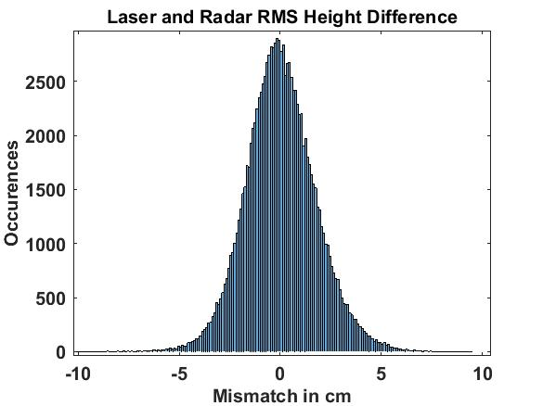

Fig. 5. Laser and Radar RMS Height Difference

In contrast, the bed roughness shows that the RMS height is lower towards the trunk of the glacier. Petermann Glacier lies in a deep subglacial trough, flanked by steep valley sides, so it is fed by large area of ice sheet [8]. The flow rate is higher towards the margin of the glacier [28]. In situ erosion of the base or marine sediments filling the bedrock gaps might have caused the bed to be smoother towards the trunk of the glacier. More detail analysis is needed for further conclusions.

# Chapter 3

# Ice Attenuation

One of the ambiguities introduced in the ice sheet modeling with radar data is introduced due to the variable ice attenuation rates. The englacial attenuation rate varies due to scattering and complicated internal structures within the ice sheet.